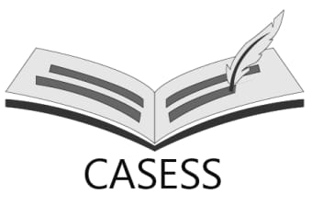  www.casess.org | Current and Advanced Academic Studies in Educational and Social Sciences  e-ISSN:

Copyright Transfer Form

Title of Article: ………
Authors Name and Surname (in order of the article):
Name Surname | Institution | Phone | E-mail
Corresponding Author must be indicated with an (*) sign

- The article titled above is the original work of the authors.
- The article has not been published elsewhere.
- On behalf of all authors as the corresponding author; I agree and undertake to transfer all financial rights on the article, especially processing, reproduction, representation, printing, publication, distribution and all kinds of transmission rights to Current and Advanced Academic Studies in Educational and Social Sciences (CASESS) Journal.

,Name and Surname of Corresponding Author | Date | Signature

